### Ideation Phase

**Brainstorm & Idea Prioritization Template**

|  |  |
| --- | --- |
| Date | 29 october 2022 |
| Team ID | PNT2022TMID29092 |
| Project Name | A Gesture-based Tool for Sterile Browsing of Radiology Images |
| Maximum Marks | 4 Marks |

#### Brainstorm & Idea Prioritization Template:

Brainstorming provides a free and open environment that encourages everyone within a team to participate in the creative thinking process that leads to problem solving. Prioritizing volume over value, out-of-the-box ideas are welcome and built upon, and all participants are encouraged to collaborate, helping each other develop a rich amount of creative solutions.

Use this template in your own brainstorming sessions so your team can unleash their imagination and start shaping concepts even if you're not sitting in the same room.

Reference: <https://www.mural.co/templates/empathy-map-canvas>

#### Step-1: Team Gathering, Collaboration and Select the Problem Statement

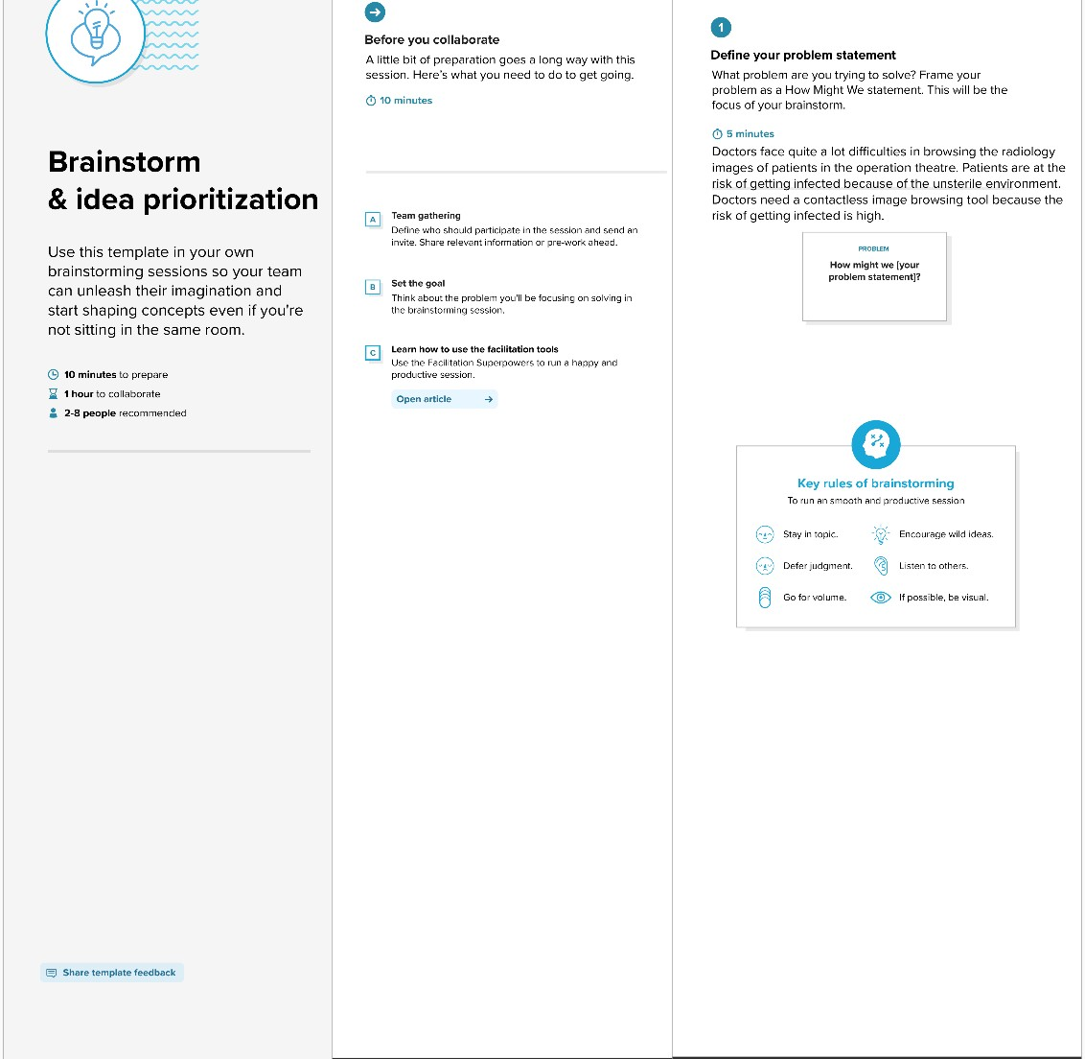

**Step-2: Brainstorm, Idea Listing and Grouping**

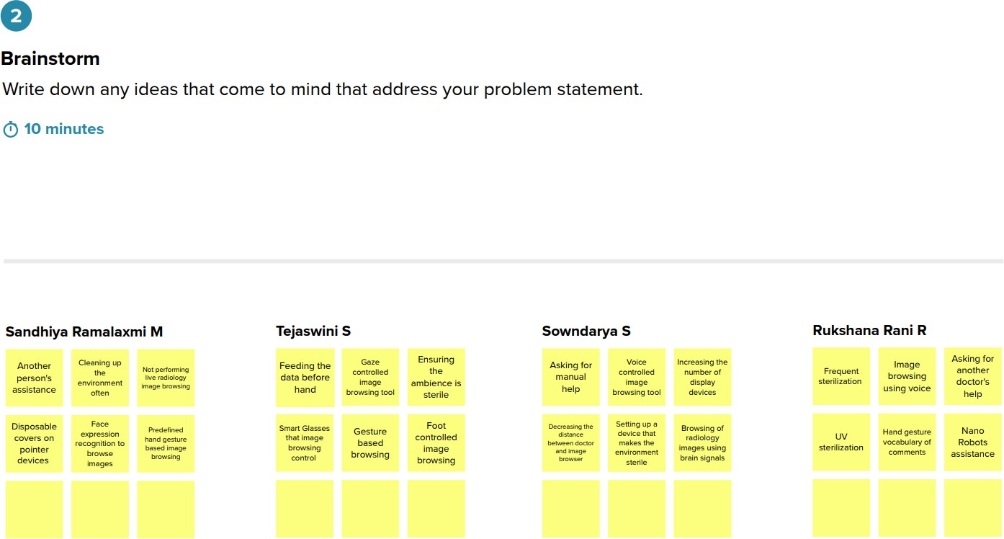

pavithra

rangalakshmi

puspakaviya

rithika



Group ideas

Take turns sharing your ideas while clustering similar or related notes as you go. In the last 10 minutes, give each cluster a sentence-like label. If a cluster is bigger than six sticky notes, try and see if you and break it up into smaller sub groups.

@ 20 min utes

# External help:

Asking for manual



Anathe r person's assistance

Asking far another doctor's help

Nano Robots assistance

Environment hygiene:

Sentng upa de+elhat makes Lhe envl ronment sterl ie

|  |  |  |
| --- | --- | --- |
| Cleaning up | Disposable | Ensuring |
| the | covers on | the |
| environment | pointer | Bmbience |
| often | devices | '^  sterile |

Frequent

sterilization

# Recognition based technological advancements:

Face exp ression

re<ognioon to brouse images

 Voice



browsing tool browsing tool

Image Gesture Hand gesture browsing @ vocabulary of using voice browsing comments

## Other Technological advances:

|  |  |  |
| --- | --- | --- |
| Browsing of | Sman Glasses | FOOD |
| radiology | that image | controlled |
| images using | browsing | image |
| brain signals | control | browsing |

Other approaches:

Nano Robots assistance

UV

sterilization

Dispa sable Decreaslng the increasing the

Not performip Feedi ng the

‹•• •^'°Wz data before

image brovzsi ’• h nd

COVOFS OF

pointer

devices

disunce

between *oo<*us*r*



browser

num ber of' devices

**Step-3: Idea Prioritization**

